

What Families Told Us
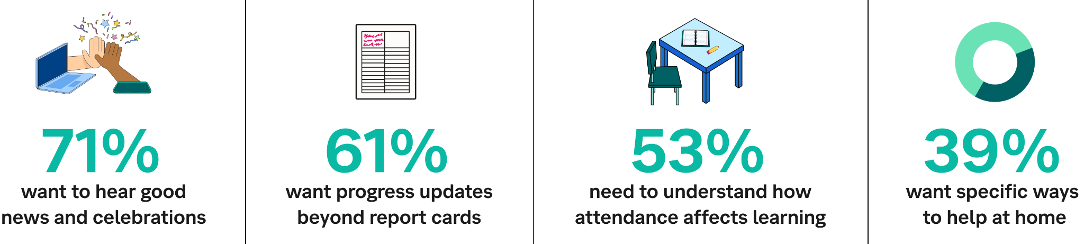
Source: 2024 Educator Report: The Critical Role of School-Home Alignment

Your Monthly Message Rotation
Send TWO messages per week to all families. Copy, paste, and personalize the [brackets]. Include the teacher’s name or class in all intros: "Hello [Ms. X's] families!" or "To all [8th grade Math] families!"

WEEK 1: Academics + Home Support 🏠
Monday: "Hello [Ms. X's] families! This week in [class]: We're covering [topic 1, topic 2, topic 3]. Ask your student what was challenging today. That's where the learning happens!"
Thursday: "To all [class] families! This week's focus: [topic]. Your student should be able to tell you about [key concept]. Questions? Reply or email."

WEEK 2: Attendance = Opportunity ⭐
Monday: "Hello [Mr. Y's] families! Students who are in school daily gain confidence, friendships, and skills. This week's highlight: [engaging activity]. Your student’s voice matters in our classroom!"
Thursday: "[Ms. X's class] update: [X]% attendance this week! Each day your student is here, they build momentum. Missed days? Reply HELP for materials."

WEEK 3: Celebrating Progress 🎉
Monday: "To all [Biology] families! Last week's wins: [specific achievements not grades]. Your encouragement at home doubles the impact!"
Thursday: "[Ms. X's] families: What went well this week for your student? Made it to school every day? Understood a hard concept? Helped someone? We celebrate all wins. Reply and share!"

WEEK 4: Choose Your Focus 🔍

Option A—Connection Check:
Monday: "[Class] families: School is about more than grades. If your student struggles with friendships or feeling connected, let's work together."
Thursday: "Monthly check for all families: Does your student feel connected at school? Reply YES, SOMETIMES, or HELP."

Option B—General Support:
Monday: "Hello families! Common challenge this month: [specific topic]. Five-minute helper: [simple strategy]."
Thursday: "How's your student doing in [class]? Reply GREAT, OKAY, or STRUGGLING. Your input helps us support them."

Option C—Stress Check:
Monday: "To all families: If your student feels overwhelmed or anxious about school, you're not alone. Support is available."
Thursday: "Stress check: How is your student managing? Reply GOOD, STRESSED, or TALK for support options."

Individual Message Bank
(Send 3-5 per week, rotating through roster)

Quick Positives:
- "[Name] asked a question that sparked great discussion about [topic]."
- "[Name] helped a classmate understand [concept]. Natural teacher!"
- "[Name] showed real growth in [specific skill] this week."

Attendance:
- "Missed [Name]'s perspective today. Hope to see them tomorrow for [activity]."
- "[Name] was here all week and is building great momentum!"
- "Noticed [Name] has missed several [day]. Can we problem-solve together?"

Support Outreach:
- "[Name] seems to be struggling with [topic/friends/mornings]. Can we talk?"
- "Want to help [Name] feel more connected. What interests them outside school?"
- "[Name] mentioned feeling [stressed/overwhelmed]. How can we help?"

Getting Started:
- Start with just Thursday messages if twice weekly feels like too much
- Use your existing platform (email, text app, whatever you have)
- Batch-write Sunday, schedule sends for the week
- No response from families? Normal – keep going
- Remember: Connection matters more than perfection

Monthly Tracking (Optional)
Week 1:  - Mon  - Thu  - Individual messages sent: ___ | Week 2:  - Mon  - Thu  - Individual messages sent: ___
Week 3:  - Mon  - Thu  - Individual messages sent: ___ | Week 4:  - Mon  - Thu  - Individual messages sent: ___
Families reached this month: / Notes for next month:

